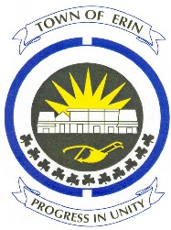

Mrs. Mardi Dinwoody & Family
For Bill Dinwoody
&
Mrs. Donna Revell

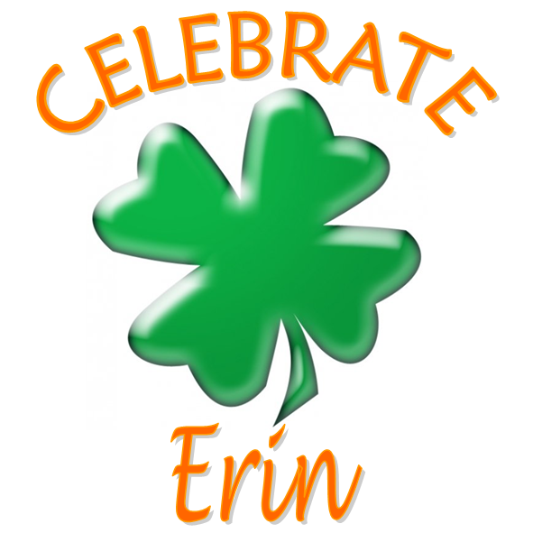
Celebrate Erin, April 23, 2016
Last November, Erin lost a strong advocate for community health care and recreation services.
Bill Dinwoody was dedicated to his family and his community. He was thoughtful, kind and soft-spoken, and had the business and personal skills to bring people together.
He was chair of the Recreation and Culture Committee and the Erin Trails group and had been about to retire from the Board of Directors at the Waterloo Wellington Local Health Integration Network, which administers provincial funding for hospitals, long-term care, community agencies and home care.
Bill had been a senior manager at the Royal Bank of Canada, and had retired after a 45-year career. He managed the strategic technology planning and developmental function, and served on national and international committees to develop a strategic technological direction for the banking industry.
He lived formerly in Toronto and Shelburne, and had a passion for outdoor activities such as hiking, horseback riding and fishing. He had been a scout leader, a ski instructor, a Sunday school teacher, a guitar player and a wood carver.
He was very active with Credit Valley Conservation, which honoured him with awards for his work on the Woollen Mills Trail and organizing tree planting projects. The next Community Tree Planting is on May 7 at the Woollen Mills Conservation Area in Erin village, starting at 9 AM, so please come out and help if you can.
Providing leadership on the Erin Trails group, Bill also helped develop the Rotary and Water Tower Trails, as well as Riverside Park, which had its official opening last year. With Recreation and Culture, he was an advocate for the Skatepark that was built next to the Centre 2000 arena.
In 2014, I accepted this award on behalf my late husband Steve, who worked on many trails projects with Bill.
And so I am very happy to make this presentation to his wife Mardi, honouring Bill Dinwoody as the 2015 Citizen of the Year.

