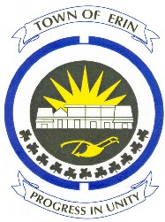

Mrs. Lorna Stewart, Randy & Jeff Stewart
For Ed Stewart
&
Mayor Al Alls

Celebrate Erin, April 23, 2016
Ed Stewart was born and raised in Ospringe and lived his entire life in the Town of Erin.
In 1955 he purchased a small garage operation from his father and started his own business. Through hard work and perseverance, Ed built that modest beginning into, what is today, one of the largest family owned agricultural equipment dealerships in Ontario.
Currently, over 50 mechanics, sales people and administration staff are employed by Ed Stewarts Equipment.
About 40 years ago, Ed joined the Erin District Lions Club and donated countless hours of his time to various club fundraising events, all for the benefit of local worthy causes.
Ed received the Melvin Jones Award of Merit from Lions International for his dedication to Lionism.

Ed was also very generous and willing to loan farm equipment to assist with local activities, such as the Erin Fall Fair, Lions’ Santa Claus Parade and many other events that required the short time use of tractors etc.

